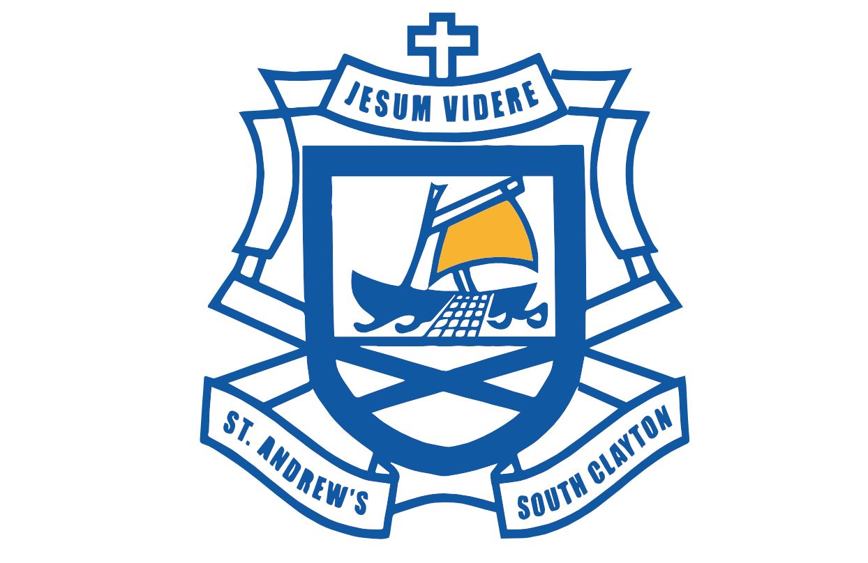
St Andrew’s School
2018-19 PHOTOGRAPH/VIDEO PERMISSION FORM

Dear Parent/Guardian,

At certain times throughout the year, our students may have the opportunity to be photographed or filmed for our school publications, such as the school’s newsletter or website or to promote the school in newspapers and other media. Further to this, classes are encouraged to publish selected work samples (including videos & photos) online in order to create a genuine audience for students’ work.

Catholic Education Melbourne (CEM) and the Catholic Education Commission of Victoria Ltd (CECV) may also wish to use student photographs/videos in print and online promotional, marketing, media and educational materials.

We would like your permission to use your child's photograph/video for the above purposes. Please complete the permission form below and return to the school by Friday 3rd February.

As newsletters will commence next and we look forward to photographing our weekly award winners, any failure to return this form will exclude your child.

Thank you for your continued support.

STUDENT’S FULL NAME: |  | YEAR LEVEL:

I give permission for (please tick ✔ all that you agree to):

Work samples (written, audio and video with no student faces) of my child to appear on teacher approved sites such as YouTube and Google Sites. Work samples may include first names only.
Photographs of my child to appear in the school newsletter, newspaper, website and promotional material. Examples include weekly award winners and excursion reports. First names will only be used in our newsletter which is emailed to the school community and password protected on the school website.
*please be aware if this box is not ticked, your child will have to be excluded from the weekly award winners photo
Photograph/video of my child to be used by the school/CEM/CECV in the agreed publications without acknowledgment, remuneration or compensation.
CEM/CECV to use the photograph/video in material available free of charge to schools and education departments around Australia for the CEM/CECV’s promotional, marketing, media and educational purposes.

Licensed under NEALS: The photograph/video may appear in material which will be available to schools and education departments around Australia under the National Educational Access Licence for Schools (NEALS), which is a licence between education departments of the various states and territories, allowing schools to use licensed material wholly and freely for educational purposes.
I understand and agree that if I do not wish to consent to my child's photograph/video appearing in any or all of the publications above, or if I wish to withdraw this authorisation and consent, it is my responsibility to notify the school.
Name of Parent / Guardian
Signed: Parent/Guardian |  | Date:

Any personal information will be stored, used and disclosed in accordance with the requirements of the Privacy Act 1988 (Cth).

